Togo

## Freedom House political status

The data set shows the Freedom House political scores and status of the country each year.

## # A tibble: 19 x 5  
## country iso3c date mean status   
## <chr> <chr> <dbl> <dbl> <chr>   
## 1 Togo TGO 1996 5.5 Not Free   
## 2 Togo TGO 1998 5.5 Not Free   
## 3 Togo TGO 2000 5 Partly Free  
## 4 Togo TGO 2002 5.5 Not Free   
## 5 Togo TGO 2003 5.5 Not Free   
## 6 Togo TGO 2004 5.5 Not Free   
## 7 Togo TGO 2005 5.5 Not Free   
## 8 Togo TGO 2006 5.5 Not Free   
## 9 Togo TGO 2007 5 Partly Free  
## 10 Togo TGO 2008 5 Partly Free  
## 11 Togo TGO 2009 4.5 Partly Free  
## 12 Togo TGO 2010 4.5 Partly Free  
## 13 Togo TGO 2011 4.5 Partly Free  
## 14 Togo TGO 2012 4.5 Partly Free  
## 15 Togo TGO 2013 4 Partly Free  
## 16 Togo TGO 2014 4 Partly Free  
## 17 Togo TGO 2015 4 Partly Free  
## 18 Togo TGO 2016 4 Partly Free  
## 19 Togo TGO 2017 4 Partly Free

## Freedom House classification of political change

The data set shows the GDP growth and the ecomic growth classification of the country each year.

## # A tibble: 19 x 4  
## country iso3c date politicalChangeFH  
## <chr> <chr> <dbl> <chr>   
## 1 Togo TGO 1996 no change   
## 2 Togo TGO 1998 no change   
## 3 Togo TGO 2000 no change   
## 4 Togo TGO 2002 autocratization   
## 5 Togo TGO 2003 no change   
## 6 Togo TGO 2004 no change   
## 7 Togo TGO 2005 no change   
## 8 Togo TGO 2006 no change   
## 9 Togo TGO 2007 democratization   
## 10 Togo TGO 2008 no change   
## 11 Togo TGO 2009 democratization   
## 12 Togo TGO 2010 no change   
## 13 Togo TGO 2011 no change   
## 14 Togo TGO 2012 no change   
## 15 Togo TGO 2013 democratization   
## 16 Togo TGO 2014 no change   
## 17 Togo TGO 2015 no change   
## 18 Togo TGO 2016 no change   
## 19 Togo TGO 2017 no change

## Freedom House score trend

The plot shows the Freedom House scores trend of the country.

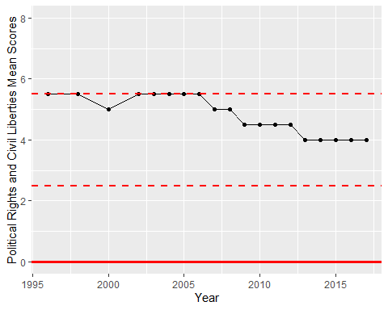

Freedom House Score Trend